A Book Recommendation System

Report Guide

Nikolaos Mparoutis

The structure of the system:


Machine Learning is software and should be treated as software.
The Object Oriented design, development and the clean code fundamentals are followed despite the much longer time of the development.

- Configurations have the yaml with the paths so that the developer to use only one place for his paths. Also, the configuration for the model(s) are in this directory and we get them as objects.
- Data has the modules related to the data modules, the loading, the cleaning, the analysis and the datasets, this directory has only datasets (acceptable only .csv, which the system checks and extracts automaticaly from the zip folder)
- Model has the stages of the build and the predictions of the model on the test data.
- Evaluaton evaluates has the model.
- Tests has the tests, in a realistic REST API product this is mandatory.
Also:
- Utils.py has some unrelated methods to calcuate the time and the memory.In order to calculate the time and memoru for each function and improve them used these methods.
- Depedencies has the requirement for installation
- Research has the research notes for the collaborative filtering.

Console output from the data pipeline and the model build with all the dataset’s records

Unique values in ISBN=271360
Unique values in Book-Title=242135
Unique values in Book-Author=102023
Unique values in Year-Of-Publication=118
Unique values in Publisher=16807

Unique values in User-ID=278858
Unique values in Location=57339
Unique values in Age=165

Unique values in User-ID=105283
Unique values in ISBN=340556
Unique values in Book-Rating=11

Some users rated books that does not exist in Books dataset
(1149780, 3)
(1033042, 3)

- Ratings - Books have FK the ISBN. We here see the number of the distinct joins on ISBN. (1.149.780, 3)
- Ratings – Book join with User using the FK User-ID, Ratings.User-ID=User.User-ID.
(1.033.042, 3)

The difference among the two cases show that some users rated books that does not exist in Books dataset. So we work with the data from the second case.

The figure shows that the higher ratings are much more that lower ratings. The Rating 8 is top. What this says to us? That the and the long tail didstribution will have the rich get richer effect neglecting some books with ratings 10 and 9.Result of the method plot_ratings_count in DataAnalysis.py

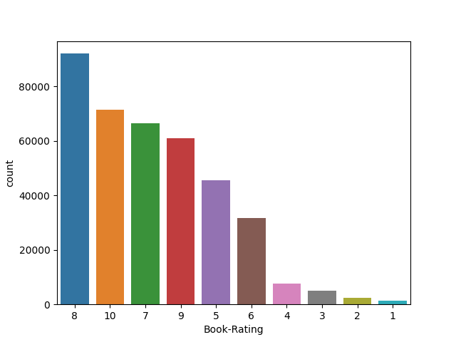

ratings from users who rated >= 50 books
User-ID ISBN Book-Rating
1456 277427 002542730 10
1458 277427 003008685 8
1461 277427 0060006641 10
1465 277427 0060542128 7
1474 277427 0061009059 9
pivoted_columns: Int64Index([ 254, 638, 1424, 1733, 1903, 2033, 2110, 2276,
2766, 2891,
...
274004, 274061, 274111, 274301, 275970, 276680, 277427, 278137,
278188, 278418],
dtype='int64', name='User-ID', length=1183)
pivoted_index: Index(['0000913154', '0001046438', '000104687', '0001047213', '0001047973',
'000104799', '0001048082', '0001053736', '0001053744', '0001055607',
...
'9997508769', '9997511417', '9997512952', '9997519086', '9997522052',
'9997555635', '9997586352', '9998150752', '9998914140', '9999669972'],
dtype='object', name='ISBN', length=86603)
pivoted majority_of_ratings (users rated at least 50 books):
ISBN 0000913154 0001046438 000104687 ... 9998150752 9998914140 9999669972
User-ID ...
254 NaN NaN NaN ... NaN NaN NaN
638 NaN NaN NaN ... NaN NaN NaN
1424 NaN NaN NaN ... NaN NaN NaN
1733 NaN NaN NaN ... NaN NaN NaN
1903 NaN NaN NaN ... NaN NaN NaN
... ... ... ... ... ... ... ...
276680 NaN NaN NaN ... NaN NaN NaN
277427 NaN NaN NaN ... NaN NaN NaN
278137 NaN NaN NaN ... NaN NaN NaN
278188 NaN NaN NaN ... NaN NaN NaN
278418 NaN NaN NaN ... NaN NaN NaN

[1183 rows x 86603 columns]
pivoted ratings (with user who rated more than 50 books). NaN replaced by 0
ISBN 0000913154 0001046438 000104687 ... 9998150752 9998914140 9999669972
User-ID ...
254 0.0 0.0 0.0 ... 0.0 0.0 0.0
638 0.0 0.0 0.0 ... 0.0 0.0 0.0
1424 0.0 0.0 0.0 ... 0.0 0.0 0.0
1733 0.0 0.0 0.0 ... 0.0 0.0 0.0
1903 0.0 0.0 0.0 ... 0.0 0.0 0.0
... ... ... ... ... ... ... ...
276680 0.0 0.0 0.0 ... 0.0 0.0 0.0
277427 0.0 0.0 0.0 ... 0.0 0.0 0.0
278137 0.0 0.0 0.0 ... 0.0 0.0 0.0
278188 0.0 0.0 0.0 ... 0.0 0.0 0.0
278418 0.0 0.0 0.0 ... 0.0 0.0 0.0

[1183 rows x 86603 columns]
model_knn: NearestNeighbors(algorithm='brute', metric=<function cosine at 0x7f15c876cae8>)
The 5 most similar users for User 3:

1: User 452, with similarity of 0.04656904902649117
2: User 130, with similarity of 0.04581293283944465
3: User 411, with similarity of 0.04531085105223287
4: User 527, with similarity of 0.0446886329651871
5: User 580, with similarity of 0.040476043856861876

Family algorithms for Collaborative Filtering
1. Memory based, are statistical like KNN.
2. Factorized - Dimensionality Reductions family
PCA, SVD, NFM, Autoencoders, Restricted Boltzman Machines.
Why i did not chose NN approaches
From previous experience with Autoencoders, Restricted Boltzman Machines
1. They require much more memory and time for training
2. The time for development is much more.
3. Also because we have to use one hot encoding this will cause the cource of dimensionality and memory crash. Neural Network are based on Cartesian Product on its fundamental level.
4. Tensor Process Unit is not available.
5. These methods does not mean significant less error if the data are not too much. Also many zeros will weak the neurons among the layers.In our case we do not have too much data.
Why i use statistical based algorithm, the KNN.
1. Because of the above 1 to 5 numbers.
Although KNN’s main disadvantage is that becoming significantly slower
as the volume of data increases, when predictions need to be made rapidly is not the best,
although the rapid new data and the fast suggestions are not the case heres.

Why selected these metrics and why the metric is very important.
In Configurations/configs_model.py: "metric": ["correlation", "cosine"]

If we use euclidean distance or other metric based on geometry we will miss the aligned users if their distance is too far away from each other because of the decision threshold. With Pearson correlation and with Cosine similarity the correlation in the first and the the angle in the second shows the similarity score. Their flatten vectors in ratings will not get cut because of the threshold.

Researchers Improve Recommendation Lists Through Topic Diversification:
1. Balancing top-N recommendation lists according to the active user’s full range of interests
2. Intra-list similarity metric.
3. Accuracy versus user satisfaction was taken account.
4. On Book dataset K-folding with parameter K = 4 and a split
Train 3/4 , Test 1/4 have less biased results.
In every machine learnning problem kfold always wins in my opinion because it considers all the opinions through cross validation.

